Nick Cardamone

ncard024@uottawa.ca

300060019

Oct 9 2020

lab one: polarization

Electromagnetic Engineering ELG 3106A

# Introduction

In electromagnetic wave theory, an EM wave is always polarised. The polarization may not be uniform or simple, but it always exists. In this lab, we will be looking at some special cases of elliptical polarization. In this type of polarization, the tip of the electric field traces out an ellipse. The tip of the magnetic field also traces out an ellipse, but they are different but related. We will just be considering the electric field for simplicity.

The objective of this lab is to create a table of values for specific angles given others. Specifically, χ and γ are given as inputs, and ψ and δ are the outputs. The description of the angles can be found in figure one. While the values for χ and γ are given in figure two.

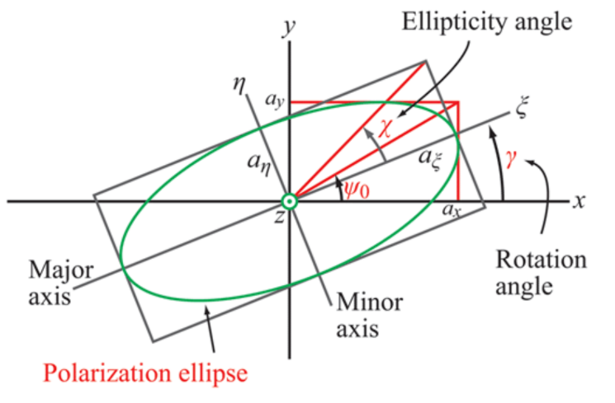

Figure : The Ellipse

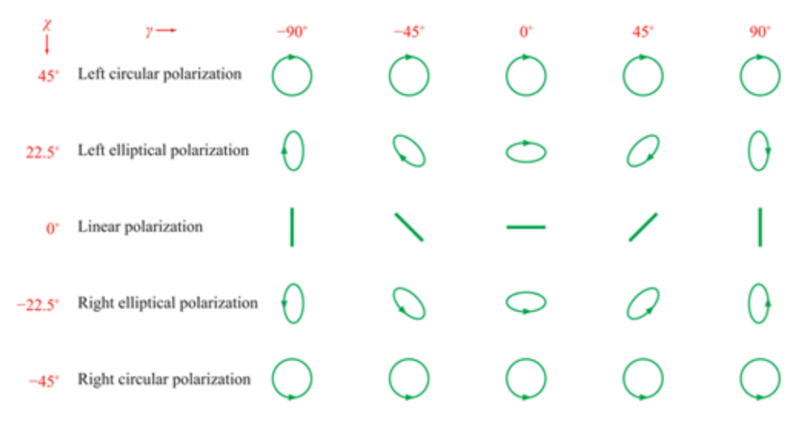

Figure : Values for χ and γ

# Theory

## Explanation

Consider a general EM wave propagating in the z-direction

$\overset{⃑}{E}\left(z,t\right)= \left[\begin{matrix}a_{x}cos⁡(ωt-kz+δ_{x}) \\ a_{y}cos⁡(ωt-kz+δ_{y}) \\ 0\end{matrix}\right] \frac{V}{m}$ [1]

We define the relative phase between the components as

$δ=δ_{y}-δ_{x}$ [2]

We can also define several parameters to describe the ellipse. For a general rotated ellipse, we define the η axis as the minor axis and ζ as the major axis of the ellipse. We then define χ, the angle between the ζ axis and a box around the ellipse as

$\tan{χ}= ±\frac{a_{η}}{a_{ζ}}$ [3]

We can also define an angle ψ to characterize how squished the ellipse is

$\tan{ψ}= \frac{a_{y}}{a_{x}}$ [4]

From the equations presented so far, we can develop two implicit trig equations as follows

$\tan\left(2γ\right)=tan\left(2ψ\right)\cos\left(δ\right)$ [5]

$\sin\left(2χ\right)=\sin\left(2ψ\right)\sin\left(δ\right)$ [6]

Solving for ψ and δ, we obtain

$\cos{(2ψ)}=\cos{(2ψ)}\cos\left(2γ\right)$ [7]

$\tan{δ}=\frac{\tan{(2χ)}}{\sin{(2γ)}}$ [8]

These two equations will be the basis for creating the data tables. The derivations for said equations are as follows

## Derivations

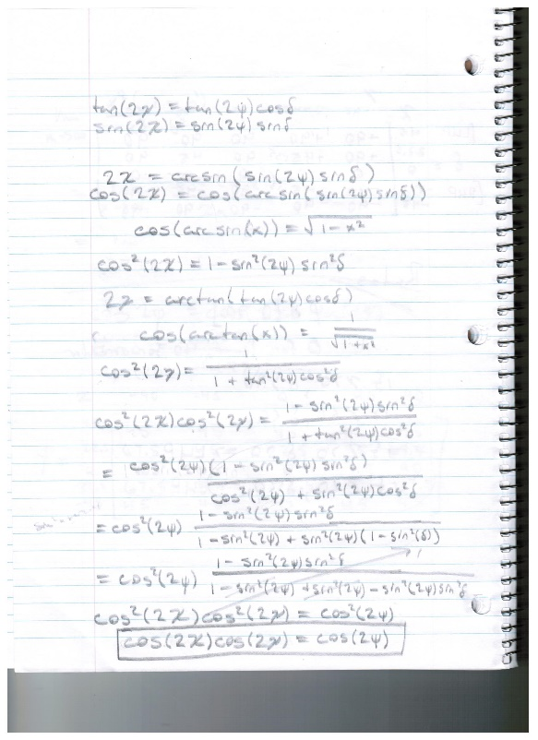 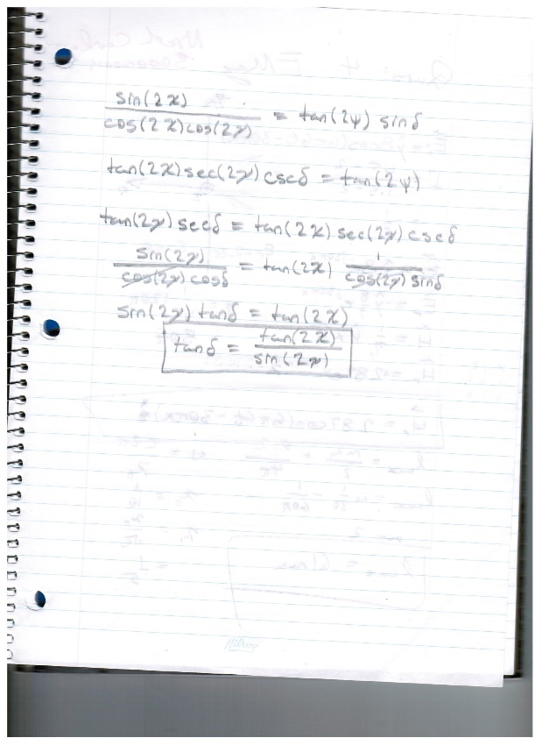

Figure : Derivation of [7] Figure 4: Derivation of [8]

# Simulation Results

## Polarization Pictures

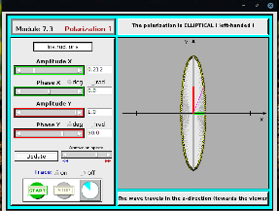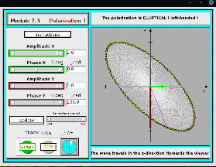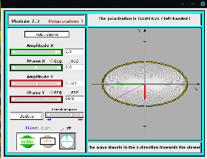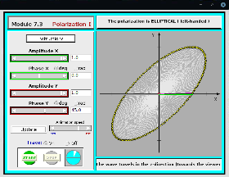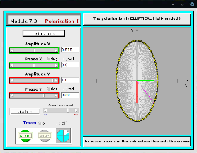

Figure : Row 2 of Simulations Results, Left Elliptical Polarizations

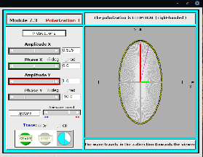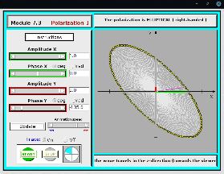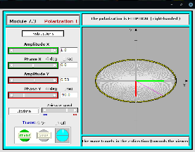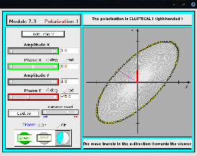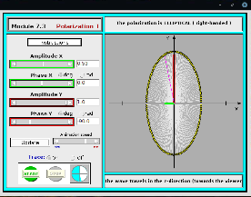

Figure : Row 4 of Simulation Results, Right Elliptical Polarizations

## Polarization Angle Data

Table : Delta Values from MATLAB

|  |  |  |  |  |  |
| --- | --- | --- | --- | --- | --- |
| χ\γ (deg) | -90 | -45 | 0 | 45 | 90 |
| 45 | 90 | 90 | 90 | 90 | 90 |
| 22.5 | 90 | 135* | 90 | 45 | 90 |
| 0 | 0 | 0 | 0 | 0 | 0 |
| -22.5 | -90 | -135* | -90 | -45 | -90 |
| -45 | -90 | -90 | -90 | -90 | -90 |

Table : Psi Values from MATLAB

|  |  |  |  |  |  |
| --- | --- | --- | --- | --- | --- |
| χ\γ (deg) | -90 | -45 | 0 | 45 | 90 |
| 45 | 45 | 45 | 45 | 45 | 45 |
| 22.5 | 67.5 | 45 | 22.5 | 45 | 67.5 |
| 0 | 90 | 45 | 0 | 45 | 90 |
| -22.5 | 67.5 | 45 | 22.5 | 45 | 67.5 |
| -45 | 45 | 45 | 45 | 45 | 45 |

## Software Explanation

The MATLAB code for this lab is relatively straight forward. Simply put, two matrices are created with the respective χ and γ values. These matrices are then fed into functions that return matrices with ψ and δ values, respectively. The functions implement equations seven and eight to get the output matrices. In earlier versions of the code, ambiguities were taken into account. However, these were not implemented in the final version because it was more efficient to fix the erroneous results manually. In other words, implementing them would violate “Henry’s First Rule of Engineering.”

# Discussion

After using the Java app to simulate the EM wave, it was clear that the MATLAB code produced at least two erroneous results, the values with the asterisk beside them. I think this happened because of the ambiguous nature of trig functions. Both of those results were 180° from where they were supposed to be. Another source of error could be from the second last step of the derivation of equation seven. In that step, a square root was taken. This may have introduced a sign error, which translates to an angle error in the results.

After the MATLAB data was collected, a process for checking the values is needed.

For ψ, there are two criteria for validation: all values must be between 0 and 90°, and there must be horizontal and vertical symmetry. Since ψ does not deal with the handedness, the symmetry of figure two is inherited.

For δ, there are again two criteria for validation, agreeing with the java app simulation and similarity in signs. The top two rows of table one must be positive, corresponding with left-handed polarization. The bottom two rows must be negative, corresponding with right-handed polarization.

# Conclusion

In conclusion, the java app was able to complement and even correct the tabulated MATLAB values. In general, δ has a strong influence on the rotation of the ellipse. The squishiness of the ellipse is influenced by ψ. χ also plays a role in the squishiness, and γ describes the rotation of the ellipse. The handedness for this lab was determined from the java app. While this could have been implemented in the MATLAB code, “Henry’s First Rule of Engineering” mandates the use of the java app.